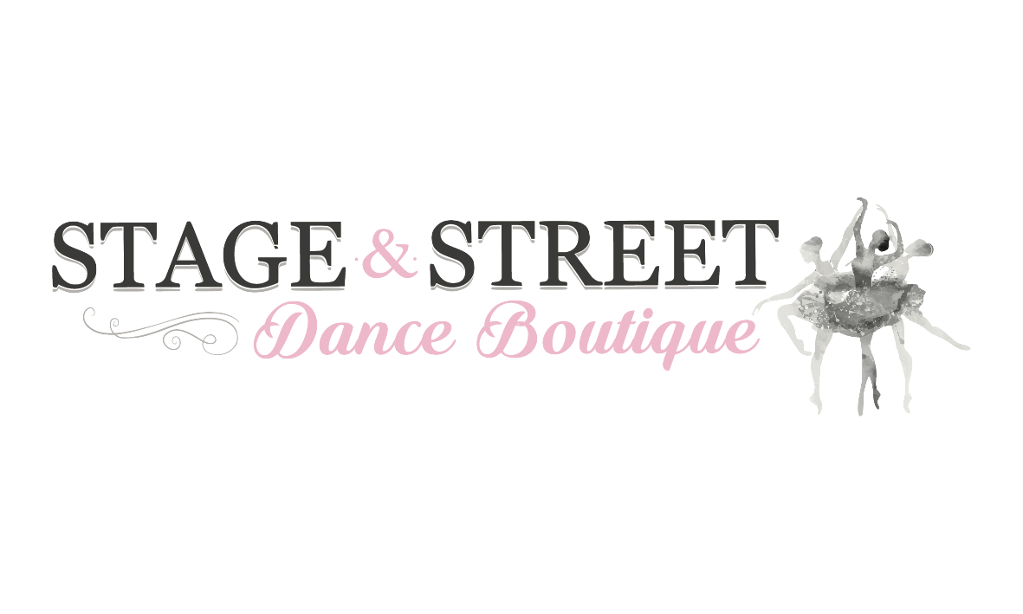

Terms and Conditions of Stage and Street Dance Boutique’s Ambassador Program
1- Dancers must have Parent/ Guardian approval to enter this competition and understand that by doing so you are committed to a minimum 12-month ambassador contract
2- Dancers MUST be available to attend the scheduled studio photo shoot at Stage and Street Dance Boutique on SUNDAY 7th MARCH 2021 (Time TBC)
3- Dancers must always maintain a positive, inclusive and encouraging profile and be actively involved in the dance community
4- Dancers are required to post a dance photo on their Instagram at least once a month and tag @stageandstreetdance and hashtag #SSDanceAmbassador21 #stageandstreetdance, dancers are encouraged to be wearing Stage and Street Dancewear. If the image is from the ambassador photo shoot dancers are required to tag @dreamdesignandphotography
5- Dream Design and Photography gift voucher is not transferable or redeemable for cash, the voucher cannot be used to purchase additional images from the ambassador photo shoot
6- Stage and Street Dance Boutique gift voucher and dance pack is not redeemable for cash nor can any of the items be returned/ exchanged
7- Dancers and/or parent/ guardians must consent to their/ their child’s image being used for advertising and marketing purposes both online and in-store by both Stage and Street Dance Boutique and Dream Design and Photography
8- If chosen as an ambassador you agree to shop exclusively at our store within a 100km radius, providing we supply or have the ability to supply the product/ brand you require. Discounts, gift vouchers and other benefits may be provided where applicable.
9- You cannot represent (model/ ambassador/ feature) any other dance stores or dance photographers within Australia to be considered for this opportunity nor can you become one during the same 12-month period if you are selected as a Stage and Street Dance Boutique ambassador
10- All other ambassador events are optional however you are encouraged to attend as many as you can. Stage and Street Dance Boutique does not guarantee we will have any other events for the ambassadors to participate in

